**IEQ PERCEPTION AND SATISFACTION AT AN ELEVATED ZONE TEMPERATURE UNDER VARYING VENTILATION AND AIR-MOVEMENT CONDITIONS**

Ayush Singh Rajput1,Bakul Sarkar2, Devi Madhumitha Narla3, Luv Singh4,   
Velugula Sreeman Raj5, Vandan Gajbhiye6

[*1*](mailto:1sriyab@iitkgp.ac.in)*ayushsinghrajput@kgpian.iitkgp.ac.in 2bakulsarkar@kgpian.iitkgp.ac.in 3narladevimadhumitha@kgpian.iitkgp.ac.in 4luvsinghar@kgpian.iitkgp.ac.in 5sreemaann2001@kgpian.iitkgp.ac.in 5gajbhiyevandan@kgpian.iitkgp.ac.in*

**Summary**

This study investigates the relationship between environmental factors and user comfort levels in indoor environments. Specifically, the effects of temperature, air quality, and ventilation on user satisfaction are examined and we employ the PMV scale to quantify the thermal sensation of the participants. We predict that the different combinations of temperature, air quality, and ventilation will have significant effects on user satisfaction levels, and some combinations will be more effective than others in providing comfortable indoor environments. Furthermore, it is speculated that there may be some discrepancy between the PMV scale readings and user feedback ratings due to the differences in regional climate and other factors between the location of the study and the location of the instrument development. We additionally speculate that there will be some collinearity between independent variables due to their common source, which may complicate the analysis of the data.

The study aims to gain a better understanding of the complex interactions between environmental factors and human behavior that contribute to overall user comfort by identifying patterns and relationships that can inform the design of more comfortable indoor environments. Additionally, we aim to identify individual differences that may affect overall comfort levels.

Overall, the findings of this study may have important implications for the design and management of indoor environments, as they can help improve user comfort and well-being. The report highlights the relevance and applicability of the study's findings for professionals in the architecture and building design fields and suggests potential areas for future research.

***Keywords:*** *Indoor Environmental Quality (IEQ), PMV, Indoor Air Quality (IAQ),*

# Introduction

A survey was conducted to improve our understanding of the comfort conditions and satisfaction perception in indoor environments (IEQ). Data was collected on temperature, air quality, and user feedback to analyze how changes in the environment were affecting the comfort levels of participants. This analysis will help identify areas for improvement and test solutions for providing better comfort.

***Hypothesis   
  
(i)*** We hypothesize that different combinations of temperature, air quality, and ventilation will have significant effects on user satisfaction levels and that certain combinations will be more effective than others in providing comfortable indoor environments.

***(ii)*** We speculate there will be significant differences in user comfort levels between the three environmental conditions and that these differences will be reflected in the PMV (predicted mean vote) scale readings taken by the instruments. However, we also hypothesize there may be some discrepancy between the PMV scale readings and user feedback ratings due to the differences in regional climate and other factors between the location of the study (India, tropical climate) and the location of the instrument development (US, cold semi-arid climate). Specifically, we expect that the instrument readings may overestimate the comfort levels of participants in the Indian environment, leading to a difference between the PMV scale readings and user feedback ratings.

***(iii)*** We hypothesize that there will be some incoherent correlations between the various environmental factors measured in this study, such as humidity, particulate matter, CO2, and others. This is due to the presence of participants in an indoor environment, which may create unique combinations of these factors that are not found in the outdoor environment. As the indoor environment is controlled and contained, these unique combinations may result in some collinearity between independent variables due to their common source (the participants). We expect that this collinearity may complicate the analysis of the data and may require additional statistical techniques to disentangle the effects of each independent variable on user comfort levels.

After analyzing the data collected in this study, we aim to gain a better understanding of the complex interactions between environmental factors and human behavior that contribute to overall user comfort. By examining the correlations between different environmental factors, such as temperature, humidity, air quality, and user feedback data, we hope to identify patterns and relationships that can inform the design of more comfortable indoor environments. Additionally, by examining the specific behaviors and preferences of the participants, we aim to identify individual differences that may affect overall comfort levels. Ultimately, our goal is to gain a more nuanced understanding of the various stakeholders involved in creating comfortable indoor environments, including designers, engineers, facility managers, and users themselves. With this knowledge, we hope to contribute to the development of more effective and user-friendly indoor environments that promote optimal comfort and well-being for all stakeholders.

**1. Methodology**

***Research Design***

Three distinct test conditions were conducted as part of the experiment, each lasting for a duration of one hour. The details of each test condition can be found in the accompanying table.

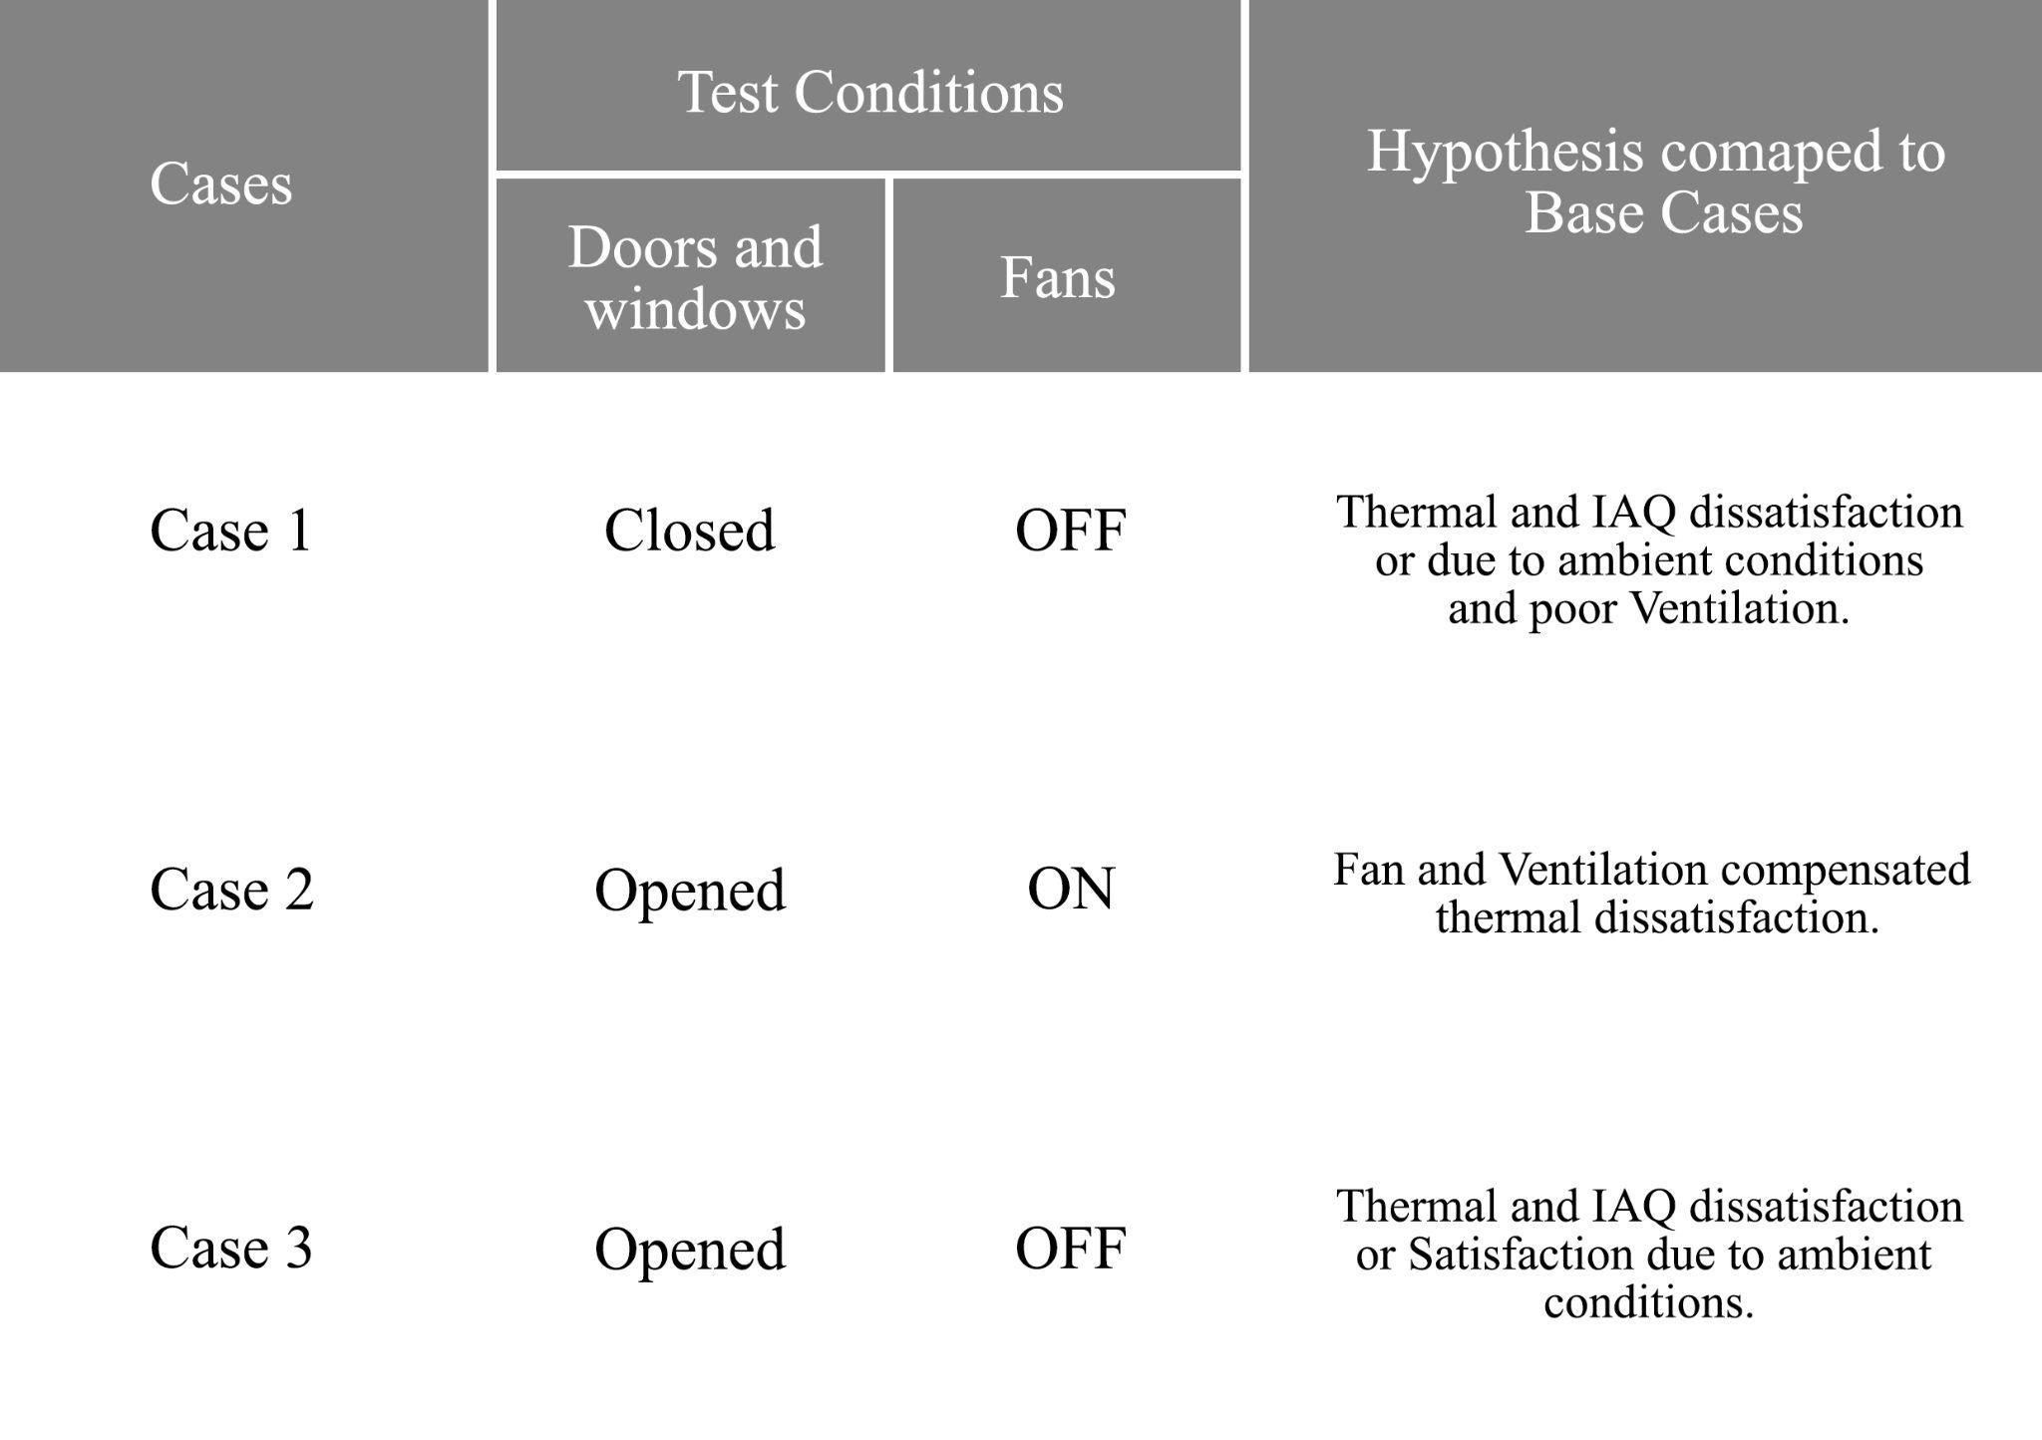

*Table 1*

Thermal comfort and air quality measurements were taken at specific intervals during the one-hour period. These intervals included 5, 15, 30, and 60 minutes respectively, and were recorded by the instrument. Additionally, feedback was obtained through the survey.

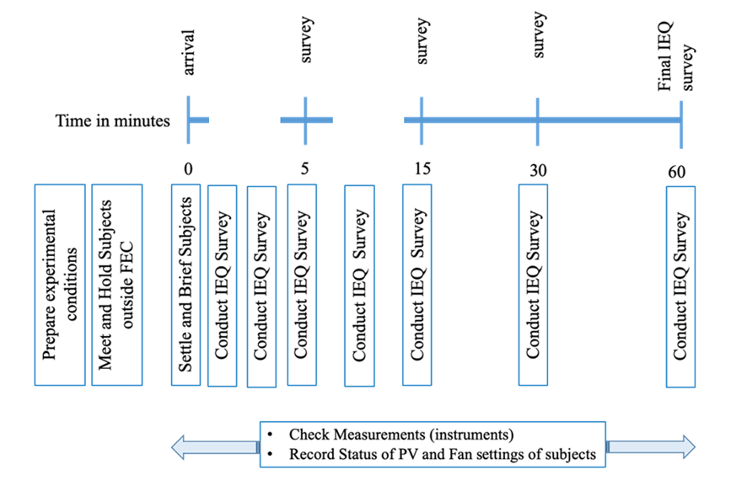

*Figure 1: IEQ Survey Flow-Chart*

Hence, the following database was collected to form a data frame for the analysis.

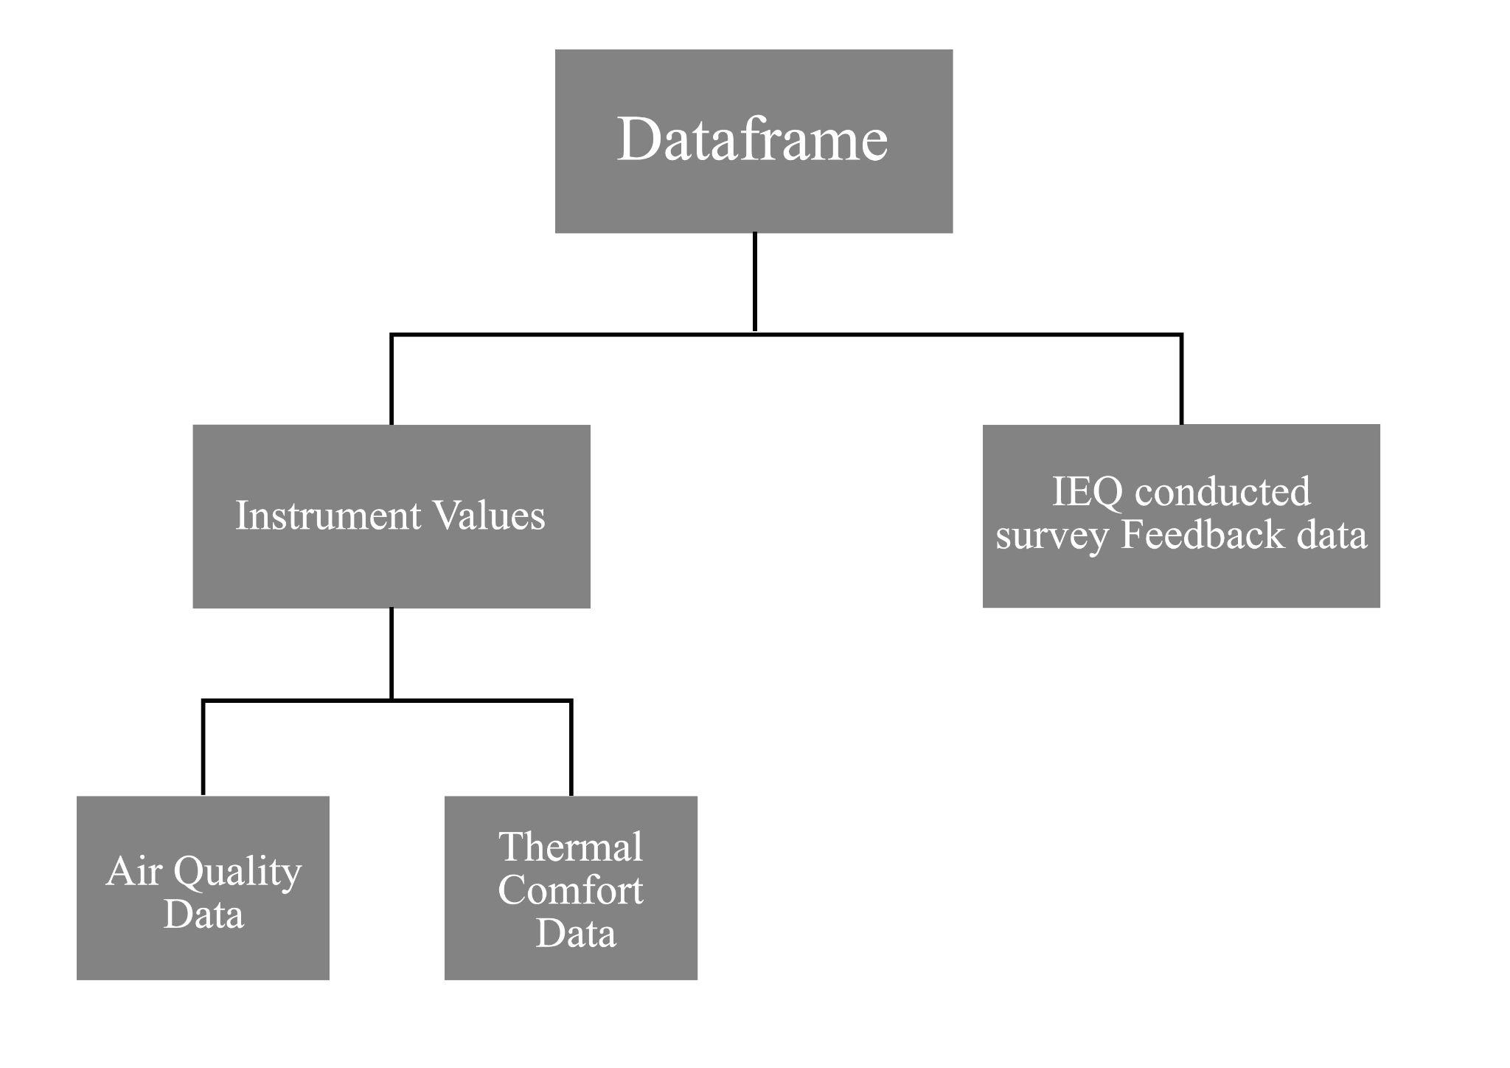

*Figure 2: Dataframe Flow-Chart*

***Cleaning the Dataframe***

During the recording of the experiment values, some human errors occurred. Specifically, for the recording at **t+5** minutes,

(i) Air Quality Data was recorded at **t+6** minutes

(ii) Thermal Comfort Data was recorded at **t+10** minutes

(iii) IEQ Satisfaction Feedback was received between **t+4** minutes and **t+12** minutes

Due to the feedback data already being collected within the time frame of **t+4** to **t+12** minutes, projecting the IAQ and thermal comfort data using the moving average to **t+5** minutes could potentially result in further discrepancies. This is because it is not possible to precisely map the feedback data to a single value as it is spread over a time frame and covers a range of air quality and thermal data inputs. Therefore, it is reasonable to assume that the measured values at time stamps **t+6** and **t+10**, along with the feedback received between **t+4** and **t+12** minutes, were all taken at the same timestamp of **t+5** minutes.

As a result, the data were grouped and organized based on specific time stamps. This was done to ensure that each set of data corresponded to a particular time stamp.

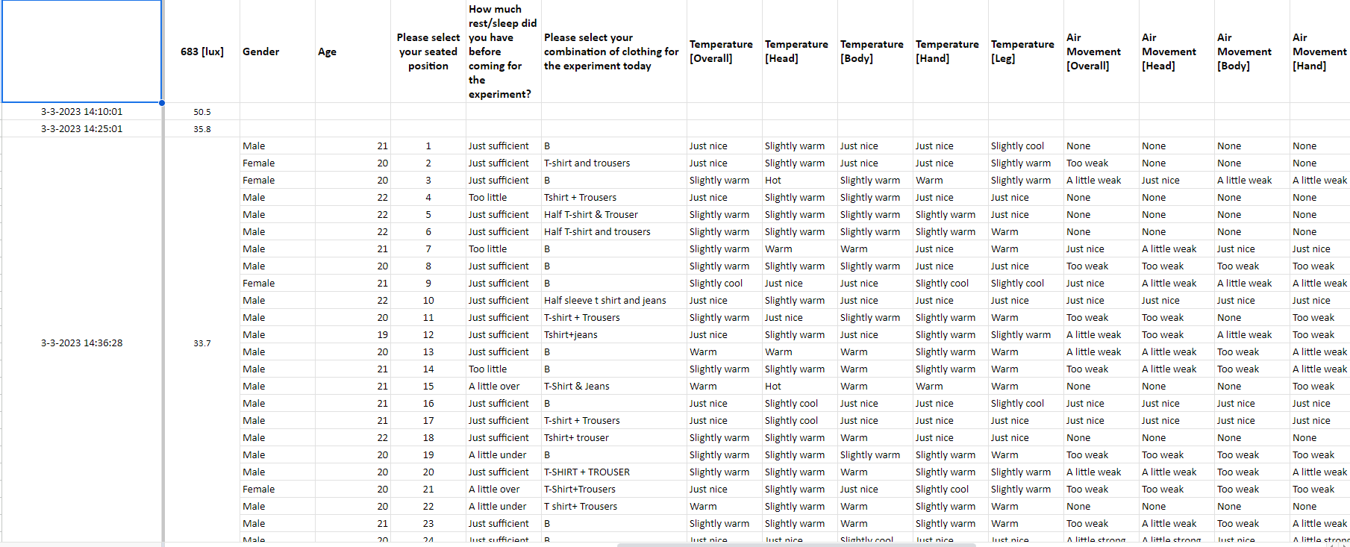

*Table 2 : IEQ Survey data*

The string inputs were converted to int using PMV (Predicted Mean Vote) metric: -3 to +3.

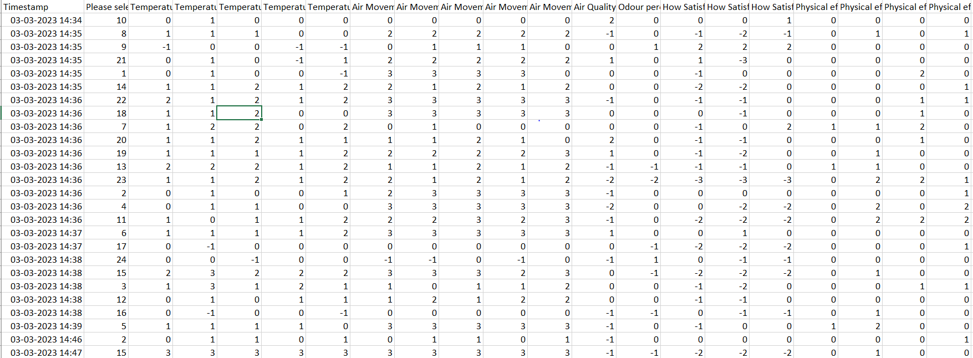

*Table 3: IEQ Survey data to PMV matrix Conversion*

NaN values were filtered for some and predicted using moving averages at other places wherever whichever was necessary. Irrelevant and unnecessary data from the dataset were also removed. (Such as Age, as everyone in the Participant Sample Set was of around the same age of 19-21)

The following were the number of feedback input taken from each seating position.



*Figure 3*

After cleaning and structuring the data, it was found that the mean and mode of the inputs were 12. However, the input from seating position 25 was removed to avoid potential discrepancies. Now that the data has been cleaned and structured, we can proceed with analyzing the collected data.

***Correlation Analysis and Collinearity***

We created a correlation matrix for all the measured data sets, which included the air quality data, thermal comfort data (compiled into one sheet), and feedback data. This was done to visualize the relationships between the variables and to identify any potential correlations that may exist.

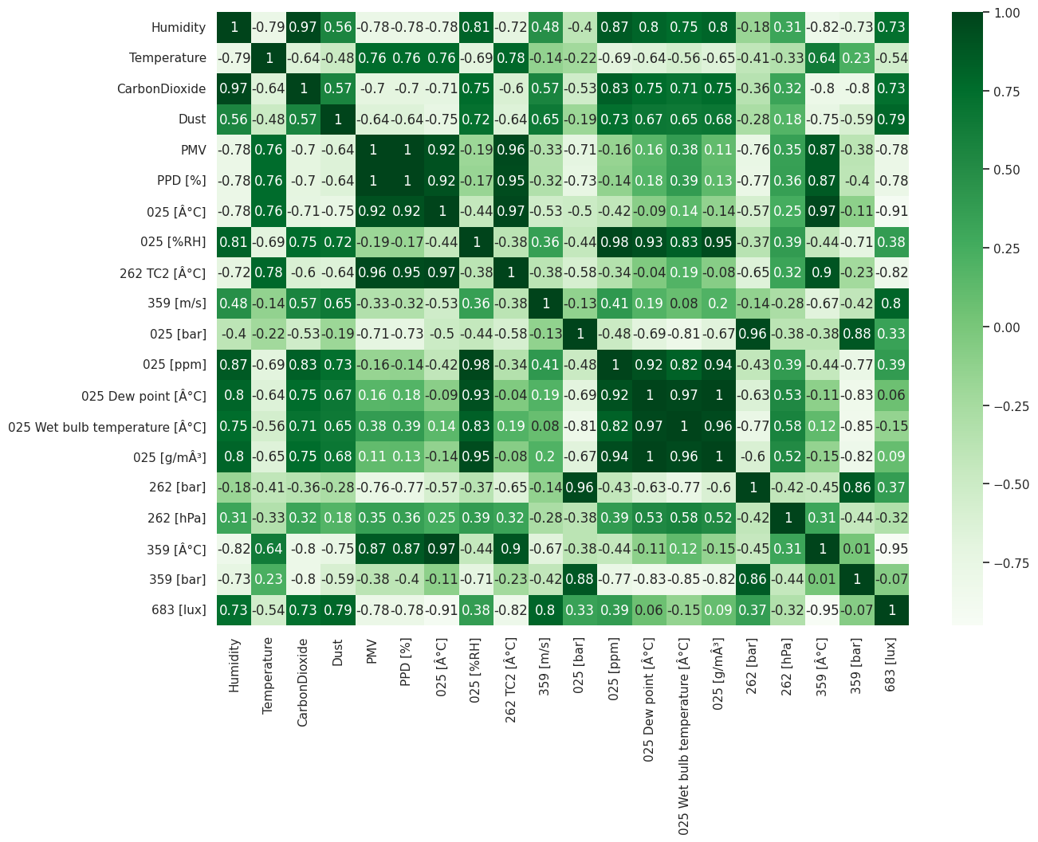

*Figure 4: Correlation Matrix Between Thermal Comfort and IEQ Survey Data*

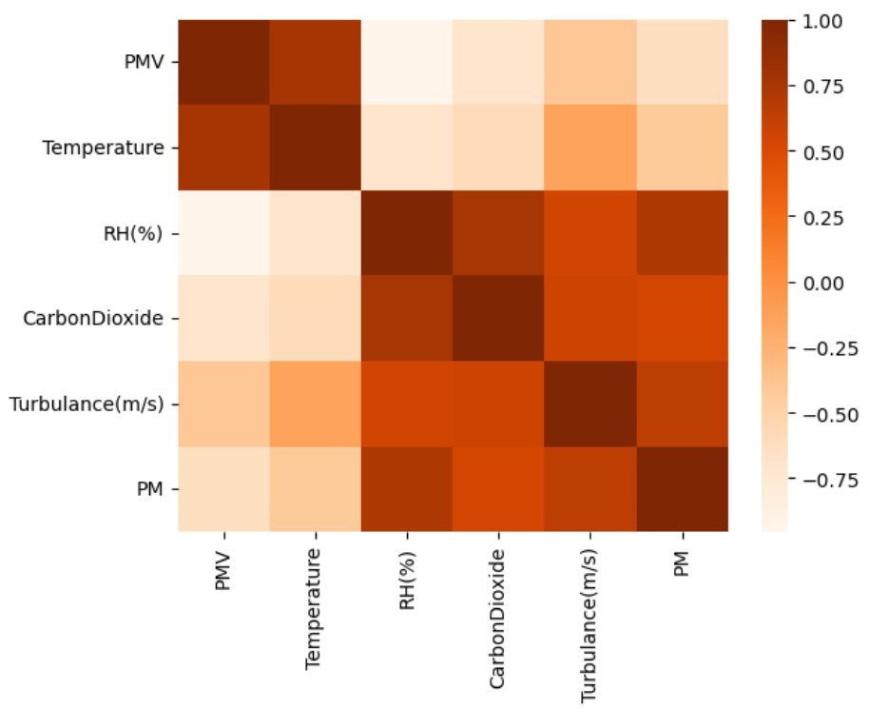

*Figure 5: Correlation Matrix of Six major Parameters*

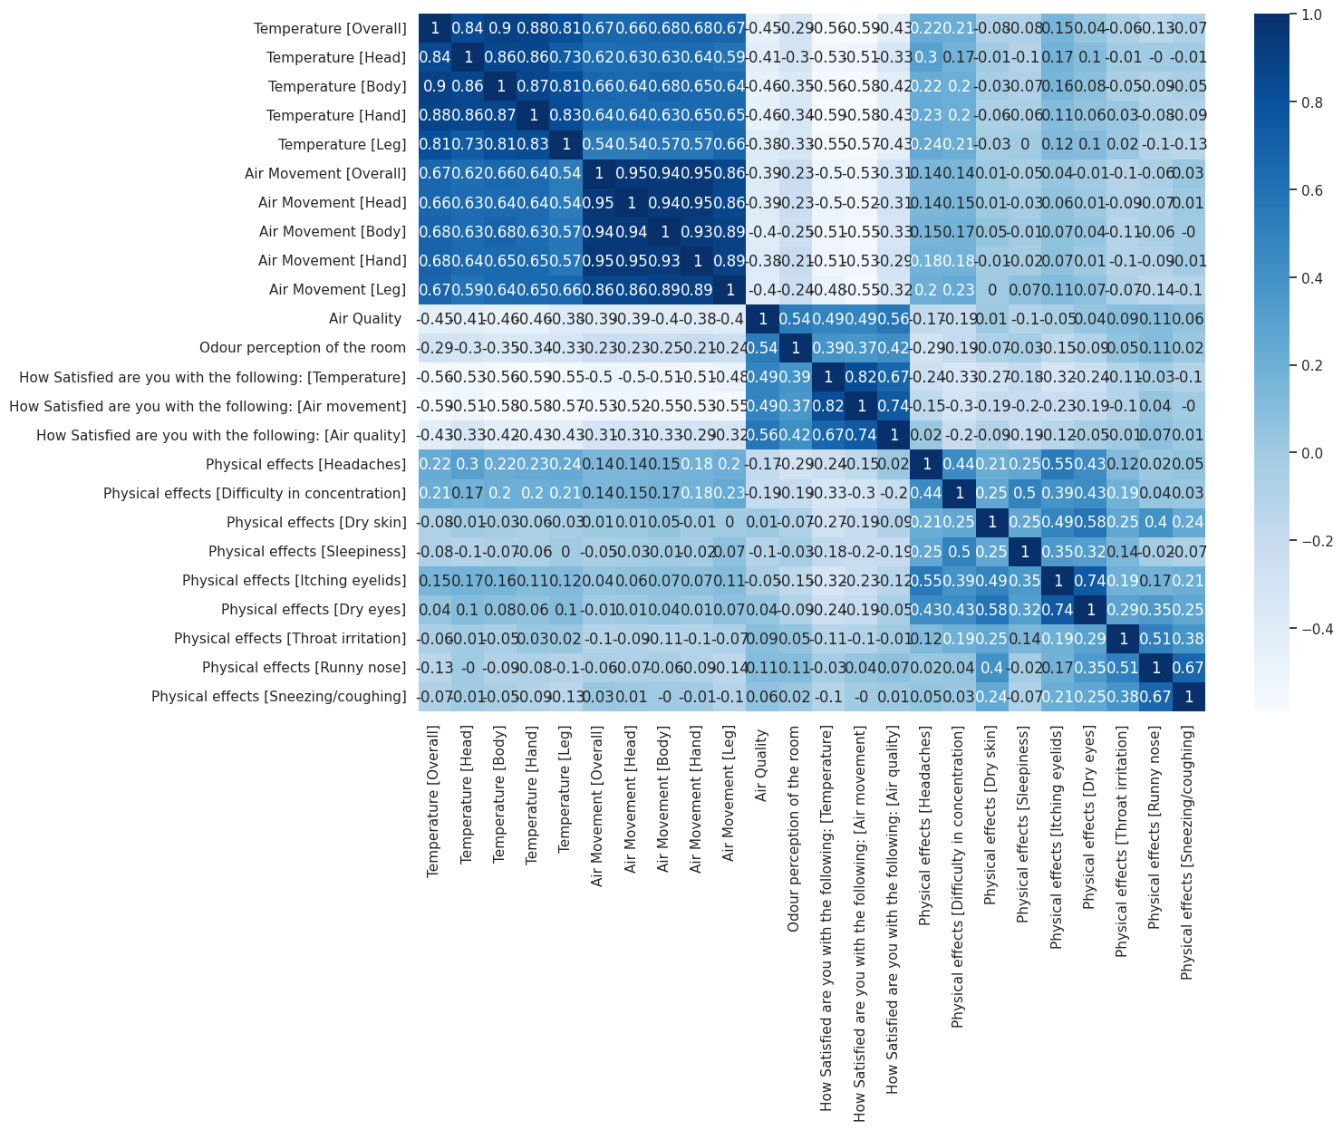

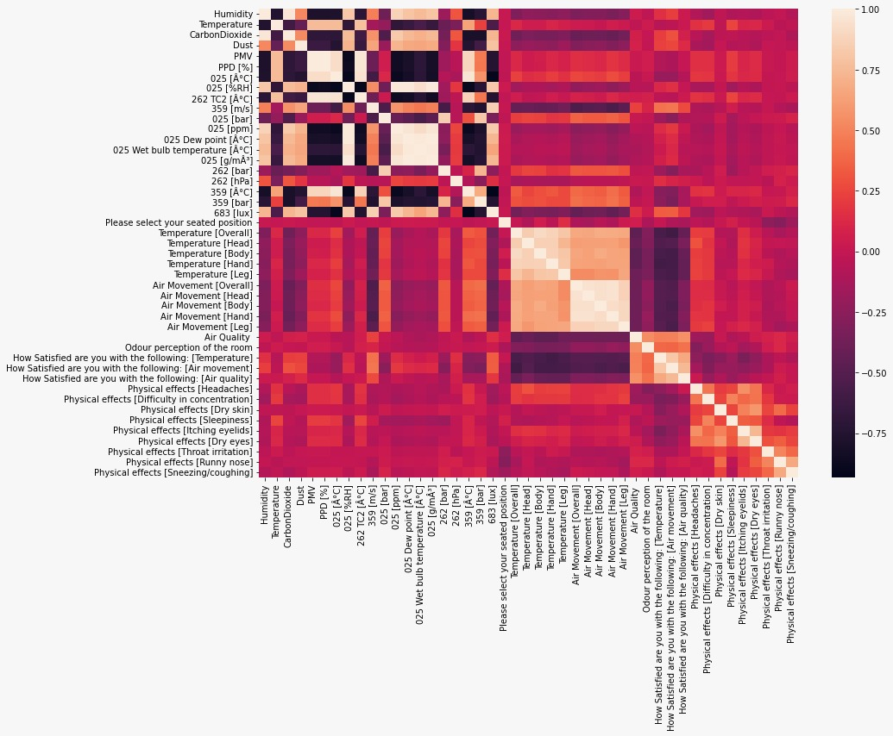

*Figure 6: Correlation Matrix of IEQ and Feedback Survey + Combined*

**Note:** Correlation doesn’t imply causation

There were both high positive and negative correlations observed between various aspects. While some of the correlations were self-explanatory, others turned out to be quite interesting. The following are the interesting correlations and anomalies from the experiment:

**From measured IAQ and Thermal Comfort Matrix**

**(i)** Relationship between PPM and Humidity, RH

**(ii)** Relationship between Humidity and Carbon Dioxide

**(iii)** High Correlation between Lux and Air Velocity, Dust, Humidity, and Carbon Dioxide as well as High Negative Correlation between Lux and PMV

**From IEQ Satisfaction feedback**

**(iv)** Relationship with Temperature [Overall] and Temperature [Head] as well as Air Movement [Overall] and Air Movement [Head]

**(v)** Relationship between how satisfied the Participant was with the Temperature v/s Air Movement

**(i) Relationship between PPM and Humidity**

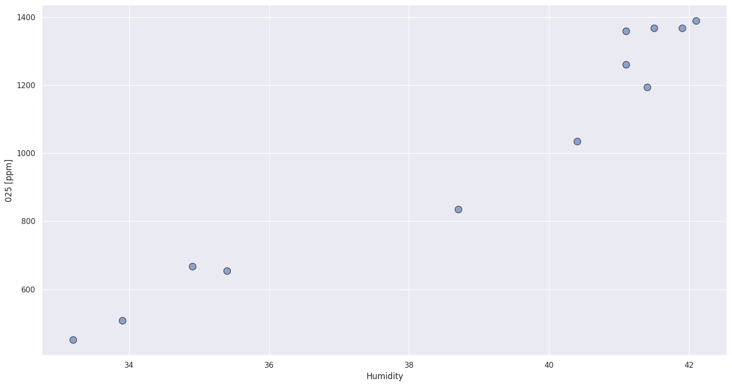

*Graph 1: PPM and Humidity*

Humidity, on the other hand, refers to the amount of water vapor in the air. High humidity levels can promote the growth of mold and other biological contaminants, while low humidity levels can cause discomfort and irritation to the skin and respiratory system.

High humidity levels can increase the size and mass of PM particles, making them easier to settle and less likely to remain suspended in the air. Conversely, low humidity levels can cause PM particles to become smaller and lighter, increasing their potential to stay suspended in the air and be inhaled.

**(ii) Relationship between Carbon Dioxide and Humidity**

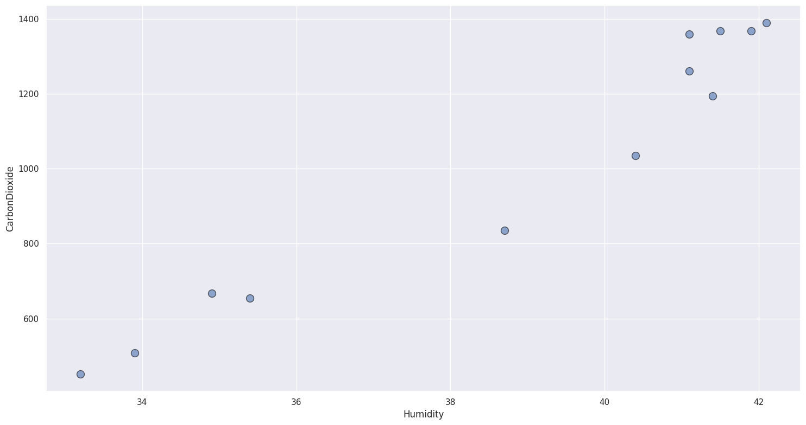

*Graph 2: Carbon Dioxide and Humidity*

In indoor situations, there is a correlation between carbon dioxide (CO2) levels and humidity levels. This correlation is due to the fact that humans exhale CO2 when they breathe, and this process also releases water vapor. As a result, the concentration of CO2 in the air can increase, leading to an increase in humidity levels as well.

The relationship between CO2 and humidity is important to consider in indoor environments because high levels of humidity can lead to problems such as mold growth, which can have negative health effects. Additionally, high levels of CO2 can cause symptoms such as headaches and drowsiness, which can be particularly problematic in workplaces or other settings where concentration and alertness are important.

**(iii) High Correlation between Lux and Air Velocity, Dust, Humidity, and Carbon Dioxide, as well as High Negative Correlation between Lux and Dry Bulb Temperature**

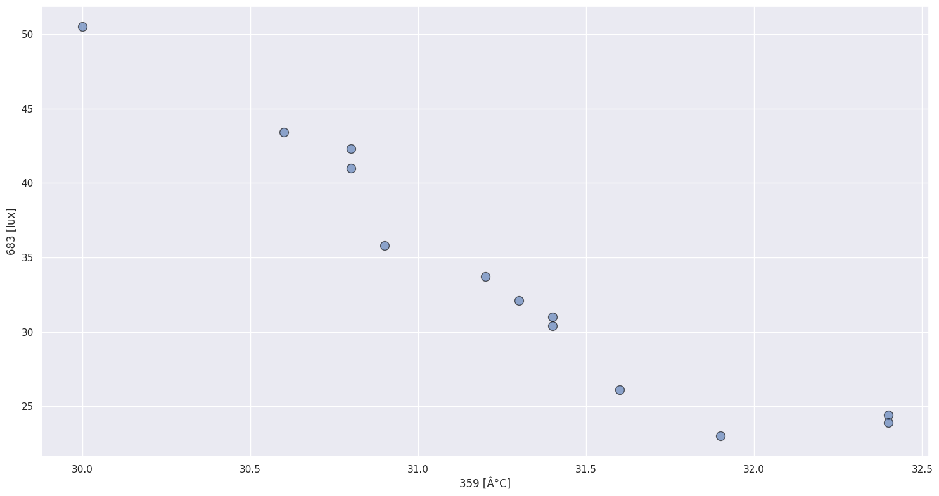

*Graph 3: Lux and Dry Bulb Temperature*

In an experimental study, measurements were taken for light intensity and dry bulb temperatures in three different scenarios. In the first case, windows were closed along with the fans, resulting in no ventilation. The second case involved opening windows and turning on fans, while in the third case, fans were turned off while the windows were left open for natural ventilation.

Surprisingly, the results did not meet expectations. There was a negative correlation between light intensity and dry bulb temperatures, whereas a positive correlation was anticipated. Upon further analysis, the presence of tinted glass on the windows was identified as a possible contributing factor. When the windows were initially closed, sunlight penetration was limited, resulting in a build-up of heat and increased dry bulb temperature. In contrast, when the windows were opened, natural ventilation occurred, allowing cooler air to flow in and reducing the dry bulb temperature.

However, the tinted glass on the windows could have also played a role in reducing the light intensity entering the room, resulting in an unexpected negative correlation between light intensity and temperature. This finding suggests that the type of glass used in windows can significantly impact indoor temperature and ventilation, and further investigation is needed to fully understand the relationship between window properties, indoor temperature, and ventilation.

**(iv) Relationship with Temperature [Overall] and Temperature [Head] as well as Air Movement [Overall] and Air Movement [Head]**

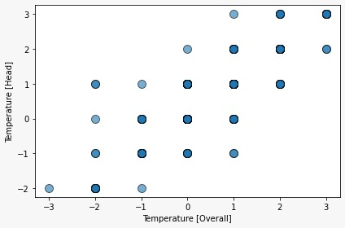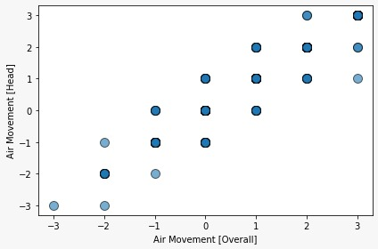

*Graph 4: IEQ Feedback Survey Temperature and Air Movement*

From a physiological perspective, the head is a major source of heat loss and is also an area where temperature can be easily affected by external factors such as changes in ambient temperature or air movement. The human body maintains a core temperature of around 98.6°F (37°C) and relies on various mechanisms to dissipate excess heat, such as sweating and vasodilation of blood vessels in the skin. Since the head has a relatively large surface area and a high blood flow rate, it can dissipate heat more easily than other body parts, leading to a cooler overall temperature sensation.

From a psychological perspective, individuals may perceive their heads as being warmer or cooler than other body parts due to the sensitivity of the skin and nerves in this area. For example, a slight breeze or draft of cool air on the face and head may create a more noticeable sensation of coolness compared to the rest of the body. Similarly, if an individual is wearing a hat or other head covering that traps heat, they may perceive their head as being warmer than the rest of the body.

Therefore, the high correlation between Temperature [Overall] and Temperature [Head], as well as Air Movement [Overall] and Air Movement [Head], can be explained by a combination of physiological and psychological factors. The head is a key area for heat dissipation and is also more sensitive to changes in temperature and air movement, leading to a closer correlation between overall temperature and air movement sensations and those experienced on the head.

**(v) Relationship between how satisfied the Participant was with the Temperature v/s Air Movement**

A high correlation was found between these two. Although note, correlation does not define causation, here it might be true due to the following hypothesis that we now propose:  
When a person is dissatisfied with the temperature, when hit with a breeze of air at the same time might feel a relatively lower temperature compared to the room temperature, hence bringing the temperature satisfaction.

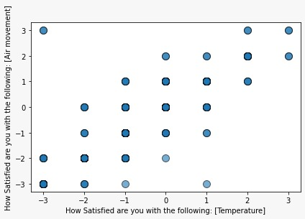

*Graph 5: IEQ Feedback Satisfaction Air Movement vs Temperature*

After mapping and understanding the correlations between various aspects, it is time to analyze the satisfaction record with respect to time. This will help us understand how satisfaction levels have changed over time and identify any patterns or trends that may have emerged.

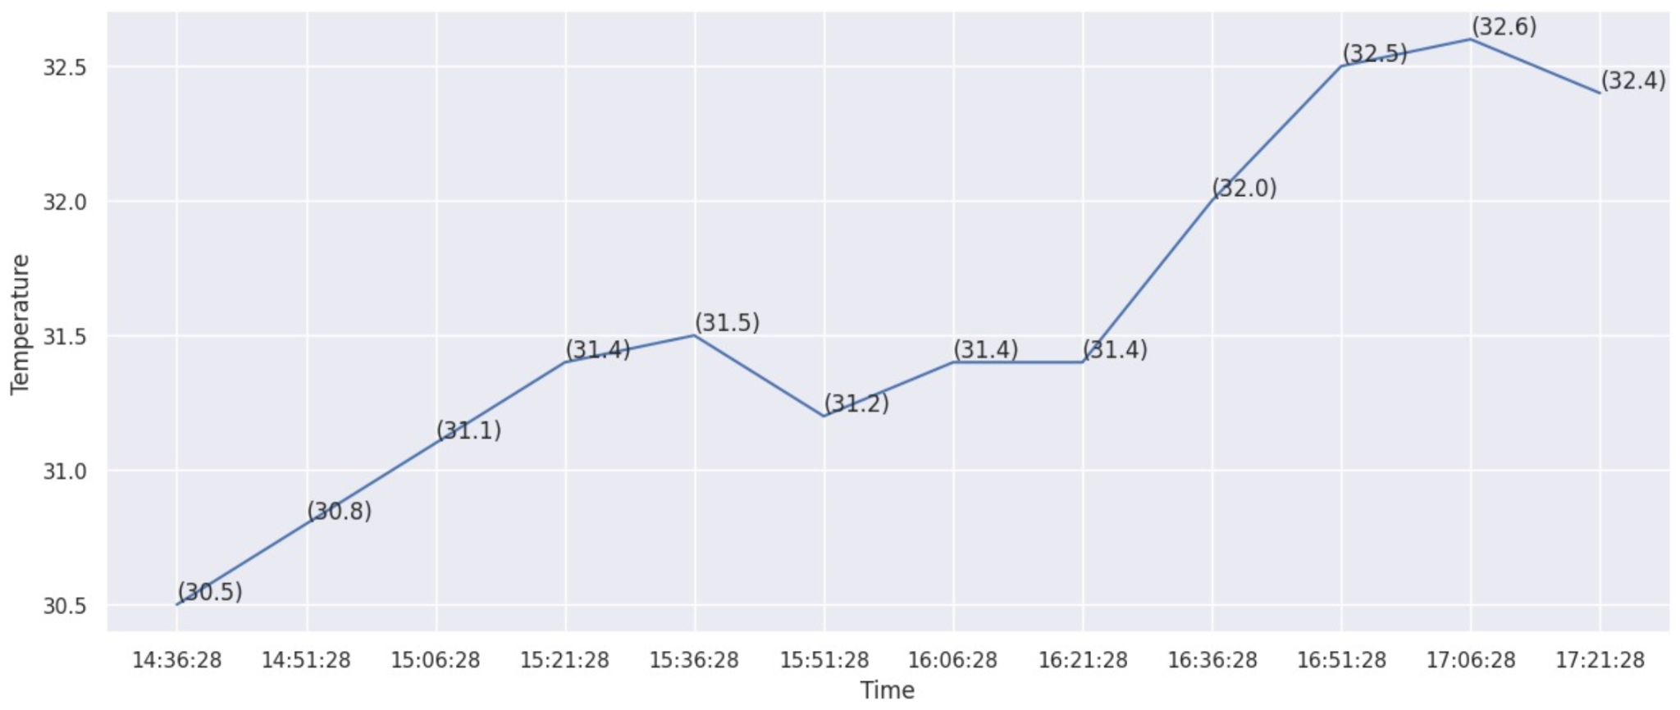

*Graph 6: Temperature and Time*

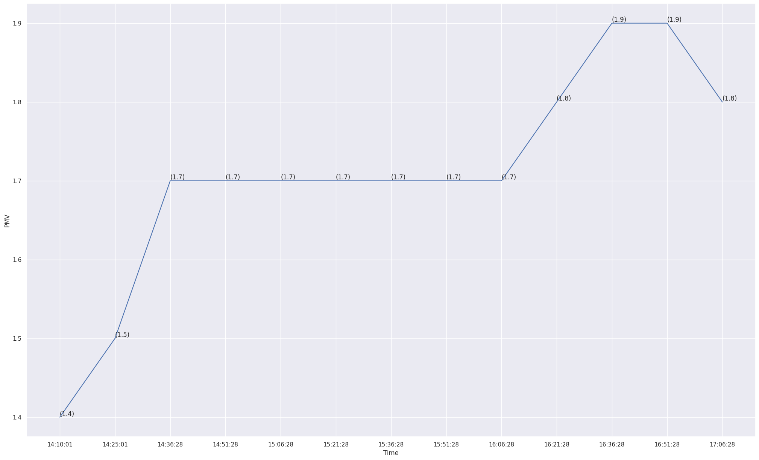

*Graph 7: PMV and Time*

The above two graphs show a rise in temperature and a rise in the PMV. There is also a high correlation between these two, as we also saw in the correlation matrix above.

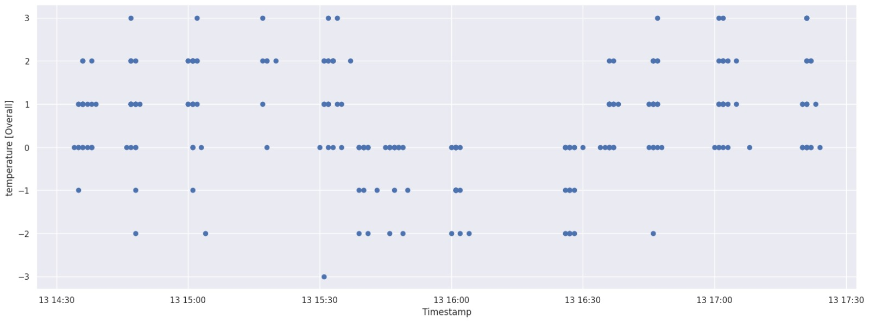

*Graph 8: Temperature and Time*

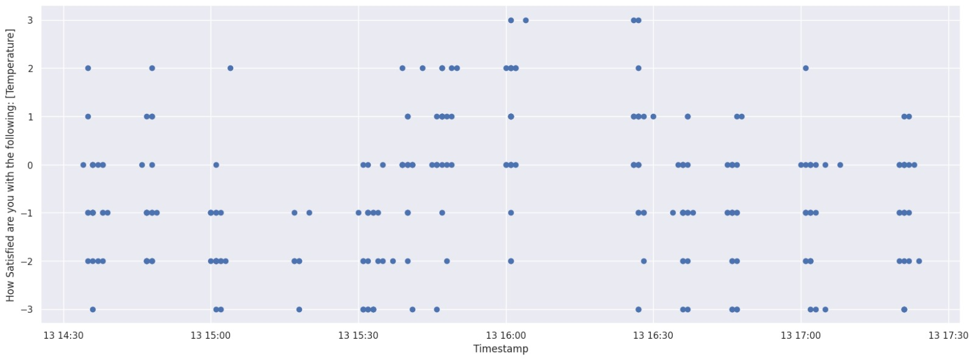

*Graph 9: Temperature and Time*

Although the recorded PMV is nowhere near what the actual Mean vote record was taken as feedback.

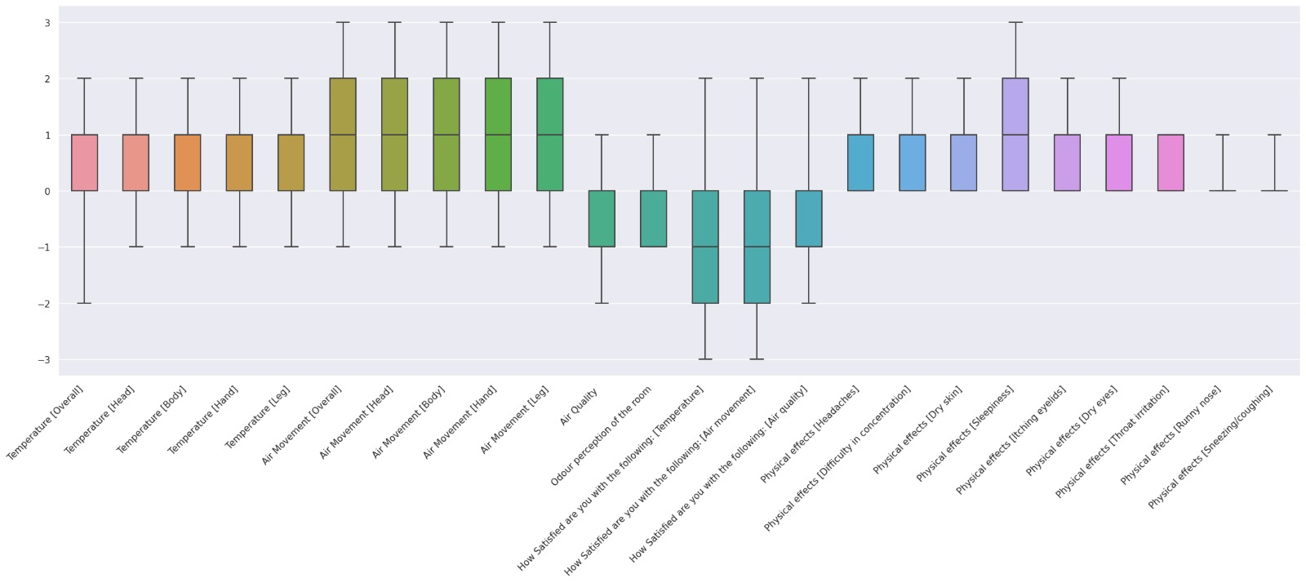

*Graph 10: Box plot of IEQ survey feedback*

From this box-plot graph, this could be read better. The following discrepancies can be seen between the recorded PMV and the thermal feedback satisfaction.  
**(i)** The box in the above graph for Temperature [Overall] lies between 0 and 1, whereas what we recorded through the experiments, we saw the values to range between 1 and 2.   
**(ii)** The PMV increased during the 3rd stage of the experiment, whereas from the scatter plot for Temperature [Overall] (from feedback) above, we saw it decreasing during the same stage.

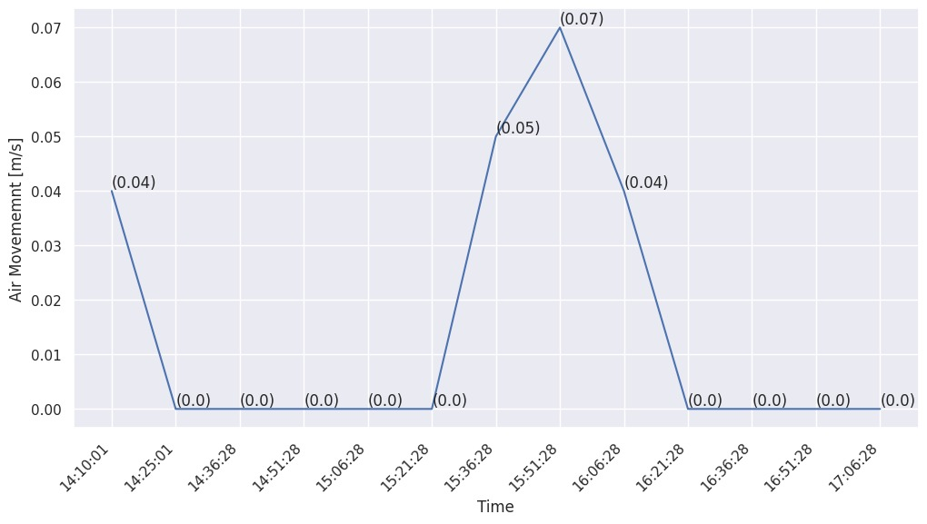

*Graph 11: Air Movement and Time*

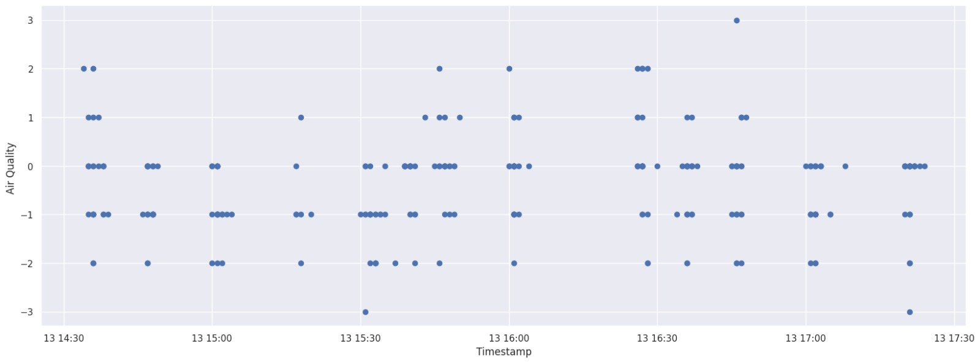

*Graph 12: Air Quality and Time*

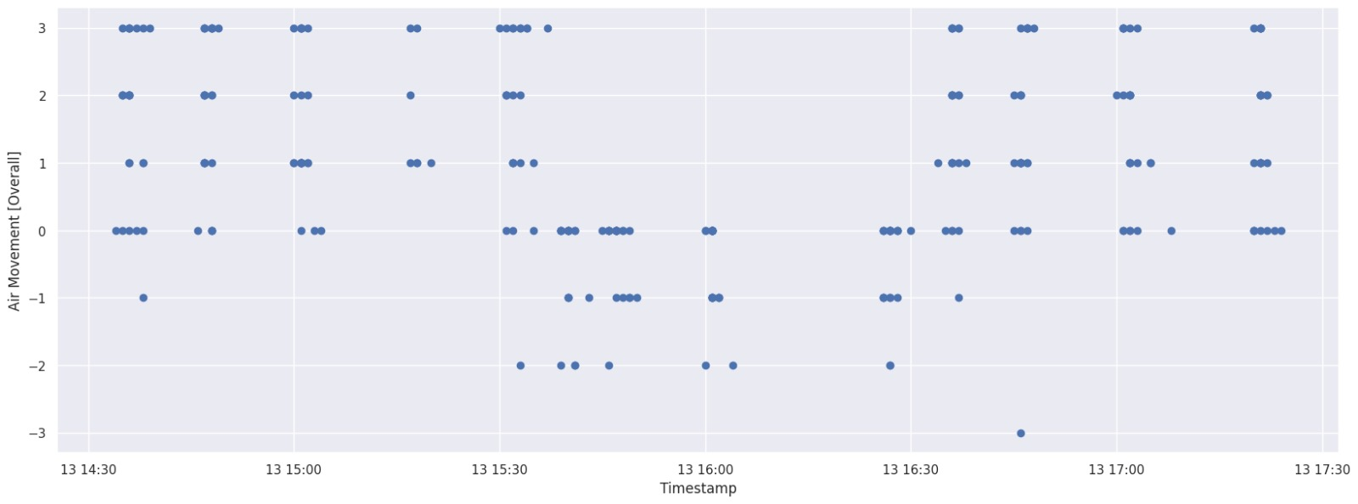

*Graph 13: Air Movement Overall and Time*

We can see the correlation between the Air Quality [Overall] and Movement graph with Air Movement [m/s] that was measured using the IAQ instruments. The increase in air movement made the participants feel the rise respectively (The metric for the Air Movement was from -3 for strong to +3 for weak).

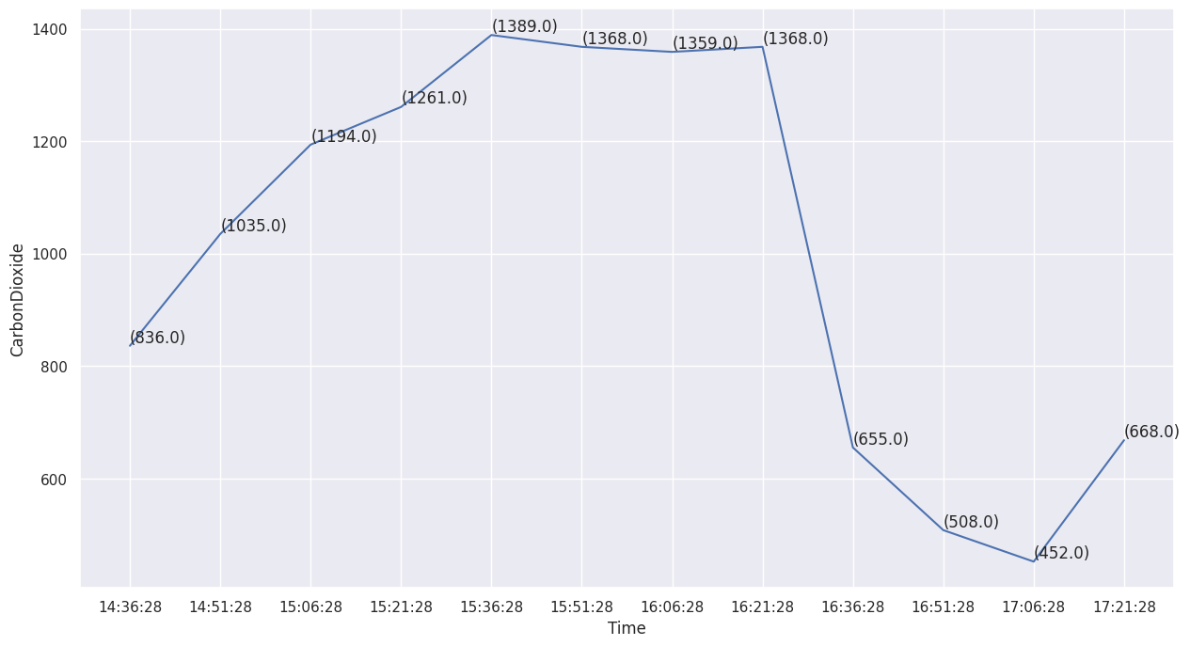

*Graph 14: CarbonDioxide and Time*

There are two discrepancies in the above CO2 vs. Time graph.

**(i)** There is a sudden dip around 16:21 hrs till 16:36 hrs. During the time, the air movement was also negligible, and hence an expected correlation is not there

**(ii)** Another discrepancy is at 17:06 hrs, where there is a sudden rise

The gradual rise in CO2 levels at the beginning of the graph can be explained by the absence of any form of ventilation. The slope of the graph changes around 15:36 hrs, and there is a slight decrease in CO2 levels due to the opening of windows and turning on of fans.

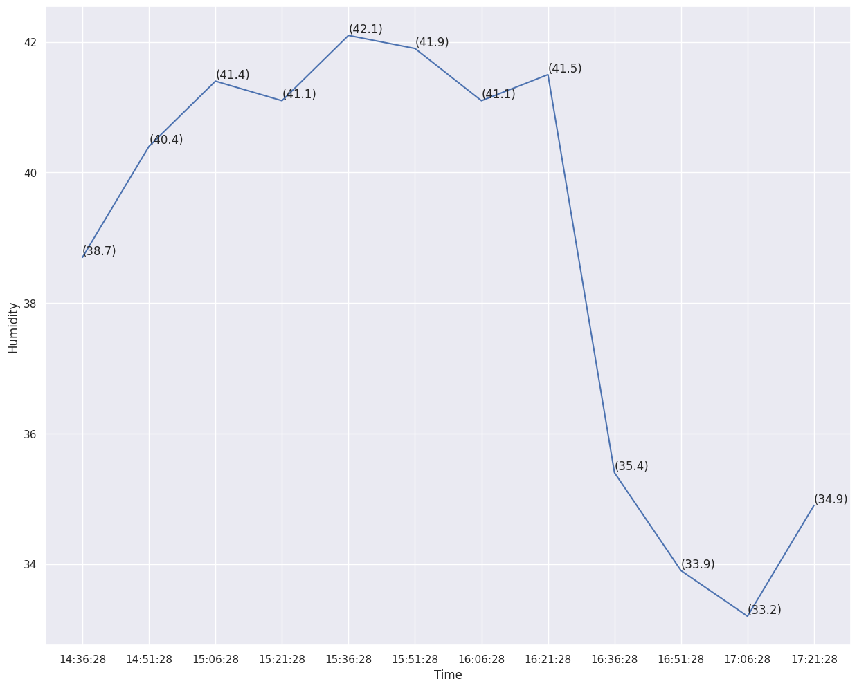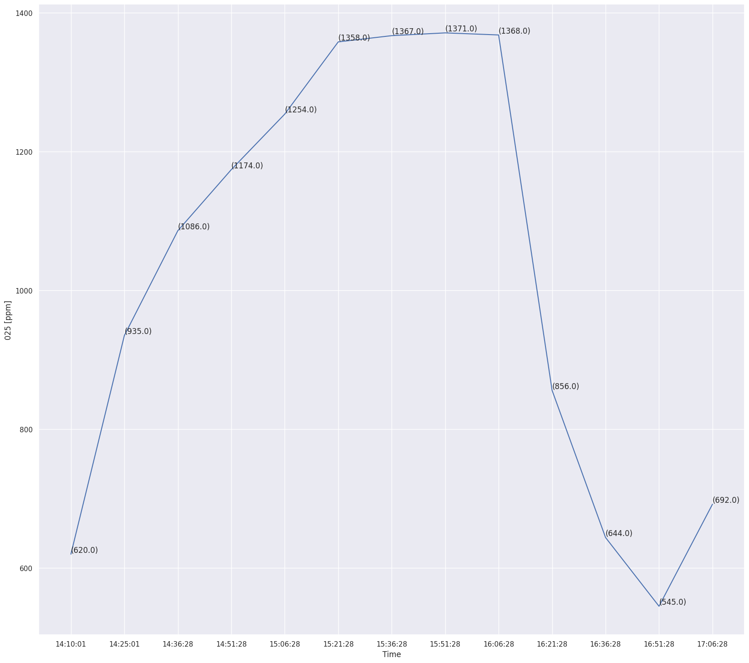

*Graph 15: Humidity and Time Graph 16: PPM and Time*

The behavior of PPM (Particulate Matter), and Humidity versus Time is similar to that of CO2 versus time. The reasoning as well as the discrepancies both are the same.

**2. Results and Discussions**

From the various graphs that were plotted and the analysis that was done, the following results were inferred

**2.1 Perception of and Satisfaction with Air Movement**

Perception and Satisfaction with air movement matched well. It sat well with the case hypothesis taken at the beginning of the methodology. During different instances, according to the surrounding conditions, the air movement was present, providing the projected satisfaction. It was also seen in the graph. Although there were certain discrepancies in Air Quality (CO2, PPM, Humidity) due to Air Movement.

**2.2 Perception of and Satisfaction with Temperature**

The recordings for PMV did not match that of IEQ Feedback Thermal Comfort Values. There were 2 major sources of discrepancies.

**(i)** The box in the box-plot graph for Temperature [Overall] lies between 0 and 1, whereas what we recorded through the experiments, we saw the values to range between 1 and 2.   
**(ii)** The PMV increased during the 3rd stage of the experiment, whereas from the scatter plot for Temperature [Overall] (from feedback), we saw it decreasing during the same stage.

**(i)** Based on the analysis conducted, it appears that there is evidence to support the hypothesis that there may be a discrepancy between the PMV scale readings and user feedback ratings due to regional climate and other factors. Specifically, the location of the study in India, which has a tropical climate, may result in differences compared to the location of the instrument development in the US, which has a cold semi-arid climate. As a result, it is anticipated that the instrument readings might overestimate the comfort levels of participants in the Indian environment. And as the overestimated value, the range for computed data came out between the range [1,2], whereas the actual Mean Vote was within the range [0,1].

**(ii)** This could be accountable to the hypothesis made during methodology where there was a high correlation between Air Movement [Overall] and Temperature [Overall].   
Air breeze can bring down the local temperature of humans due to the evaporation of sweat, resulting in cooling. In tropical climates like India, where people sweat more due to the hot, humid weather, Air Movement and brings more relief compared to a semi-arid climate region like the USA. Hence, again coming, down to the error due to the differences between the location of the study and the location of instrument development.  
  
Although, the experiment stood up to the case hypothesis that was made while segregating cases at the time of methodology. The PMV values that were recorded through the instruments were inadequate.

**2.3 Perception and Satisfaction of zone air quality**

The relationship between air quality and air movement is an important aspect of indoor environmental quality. Air movement can influence the dispersion and concentration of pollutants, which can have a significant impact on human health and comfort. When air movement is weak, pollutants can accumulate in the air and cause discomfort, while strong air movement can help disperse pollutants and improve overall air quality.

The correlation between air quality and air movement can be observed in the Air Quality [Overall] and Movement graph, which shows a positive relationship between these two variables. As air movement increases, participants report feeling a corresponding increase in air quality. This is reflected in the metric used for air movement, which ranges from -3 for strong to +3 for weak. When air movement is weak (i.e., a high negative value on the metric), participants may experience discomfort due to stagnant air and high concentrations of pollutants. On the other hand, when air movement is strong (i.e., a high positive value on the metric), participants may experience improved air quality and a greater sense of comfort. The gradual rise in CO2 levels at the beginning of the graph can be explained by the absence of any form of ventilation. The slope of the graph changes around 15:36 hrs, and there is a slight decrease in CO2 levels due to the opening of windows and turning on of fans.

An increase in Air movement also influences proper ventilation and maintains the circulation of air. A slight dip was observed in CO2, PPM, and Humidity values as soon as air was allowed to enter the room.

Although, discrepancies occurred in all three graphs 2 times.  
**(i)** There is a sudden dip around 16:21 hrs till 16:36 hrs. During that time, the air movement was also negligible, and hence an expected correlation is not there

**(ii)** Another discrepancy is at 17:06 hrs, where there is a sudden rise

For **(i)**, since no air movement was not a factor, the sudden dip in the graph could be due to many participants leaving the classroom during the time for various reasons, and for **(ii),** there was a crowd accumulated around the measuring instruments during the end of the class, which would explain the sudden rise in CO2, Humidity, PPM.

**2.4 Acute Health Symptoms**

From the combined Correlation Matrix of Figure 6, no direct/interesting positive or negative correlation was found between any health symptom and any IAQ, Thermal Comfort, or feedback data. This could be because the exposure to poor ventilating conditions was still low, and the sample set was very small and healthy.

**3. Limitations with Study and Future Scope of Improvement**

The study identified a significant limitation related to errors in calculating PMV due to differences in the region/country of study and the region/country of instrument development. However, there is potential for improvement in future studies by developing a PMV metric that takes the Indian context into account. This would involve developing new weights for different factors that are specific to India's climate and other environmental factors.

Additionally, the use of a neural network model that incorporates people's thermal satisfaction levels as features could also improve PMV calculations. By considering these factors, it may be possible to more accurately assess thermal comfort in the Indian context and potentially in other regions with unique environmental conditions as well. Further research is needed to explore these possibilities and develop more effective methods for assessing thermal comfort.

**4. Conclusions**

In conclusion, this study has aimed to assess indoor environmental quality and its impact on human health and comfort in a classroom setting in India by collecting data on temperature, air quality, and air movement, as well as measuring participants' perceptions and satisfaction levels through surveys and feedback.

The results have revealed some interesting insights into the relationship between environmental factors and human comfort. The study found that air movement and air quality were important factors in determining thermal comfort, with a positive correlation between air movement and perceived air quality. However, the study also found discrepancies between the PMV scale readings and user feedback ratings, suggesting the need for a PMV metric that takes the Indian context into account.

One of the main limitations of the study was the small sample size, which may have impacted the generalizability of the results. However, the findings provide a starting point for further research into indoor environmental quality and human comfort in Indian contexts. Future studies could further explore the relationship between environmental factors and human comfort, potentially by incorporating machine learning techniques that can better account for individual differences in preferences and physiological responses. Additionally, future studies could explore the impact of different environmental factors on cognitive performance, as well as the potential for smart building technologies to improve indoor environmental quality and human comfort.

Overall, this study provides important insights into the impact of indoor environmental quality on human health and comfort in India. By better understanding the factors that influence thermal comfort, we can develop more effective strategies for improving indoor environmental quality and promoting human health and well-being.

**References**

*Fig. 1 Indoor air levels of CO2 concentration (ppm) and relative. . .* (n.d.). ResearchGate. <https://www.researchgate.net/figure/ndoor-air-levels-of-CO2-concentration-ppm-and-relative-humidity-results-of_fig1_269856111>

Kliengchuay, W., Meeyai, A., Worakhunpiset, S., & Tantrakarnapa, K. (2018). Relationships between Meteorological Parameters and Particulate Matter in Mae Hong Son Province, Thailand. *International Journal of Environmental Research and Public Health*, *15*(12), 2801. <https://doi.org/10.3390/ijerph15122801>

Kabanshi, A., Yang, B., Sörqvist, P., & Sandberg, M. (2017). Occupants’ perception of air movements and air quality in a simulated classroom with an intermittent air supply system. *Indoor and Built Environment*, *28*(1), 63–76. <https://doi.org/10.1177/1420326x17732613>

Tan, C. L., & Knight, Z. A. (2018). Regulation of Body Temperature by the Nervous System. *Neuron*, *98*(1), 31–48. <https://doi.org/10.1016/j.neuron.2018.02.022>

Chen, L., Zhang, J., & You, Y. (2020). Air pollution, environmental perceptions, and citizen satisfaction: A mediation analysis. *Environmental Research*, *184*, 109287. <https://doi.org/10.1016/j.envres.2020.109287>

Haselsteiner, E. (2021). Gender Matters! Thermal Comfort and Individual Perception of Indoor Environmental Quality: A Literature Review. *Future City*, 169–200. <https://doi.org/10.1007/978-3-030-71819-0_9>

*Figure 7: Perceived Satisfaction on the air movement in the classroom*. (n.d.). ResearchGate. <https://www.researchgate.net/figure/Perceived-Satisfaction-on-the-air-movement-in-the-classroom_fig1_305309602>